**Active class week 6**

**Group members:**

**Jasveena**

**Archit chandna**

**Nadiya**

**Gitanshi**

**Pranika**

Activity 1   
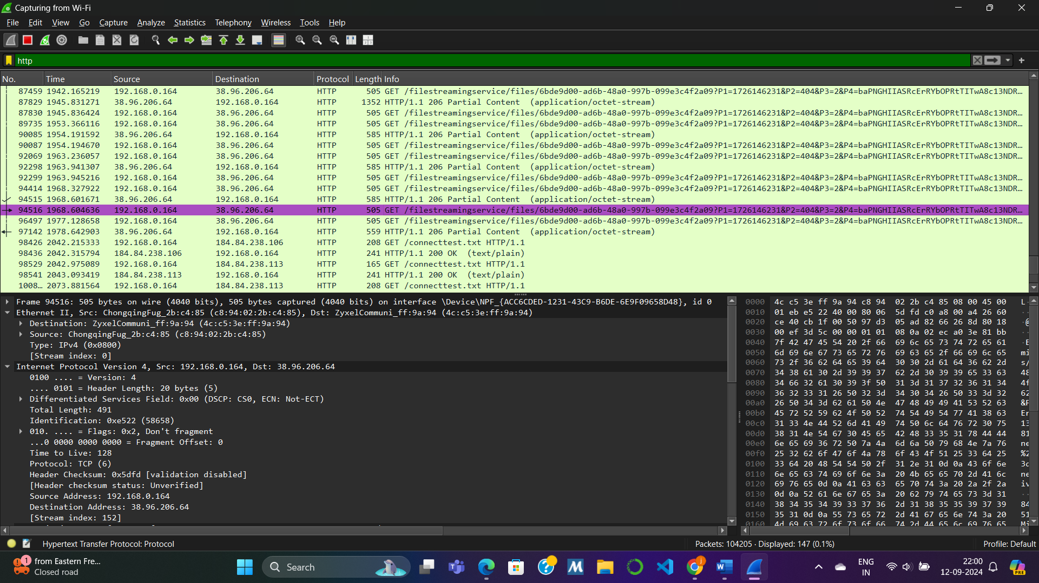  
1. HTTP Packet Analysis:

· Device IP: 192.168.0.164

· Destination IP: 38. 96. 206. 64

· IP Version: IPv4

· Transport Layer Protocol: TCP (matches with packet details)

· IP Header Size: 20 bytes

· Payload Size: 439 bytes (calculated by subtracting header size from total length: 439 - 20)

· Fragmentation: Not fragmented ("Flags: Don’t fragment")

· Other Important Fields: Total Length: 491 bytes, TTL: 128

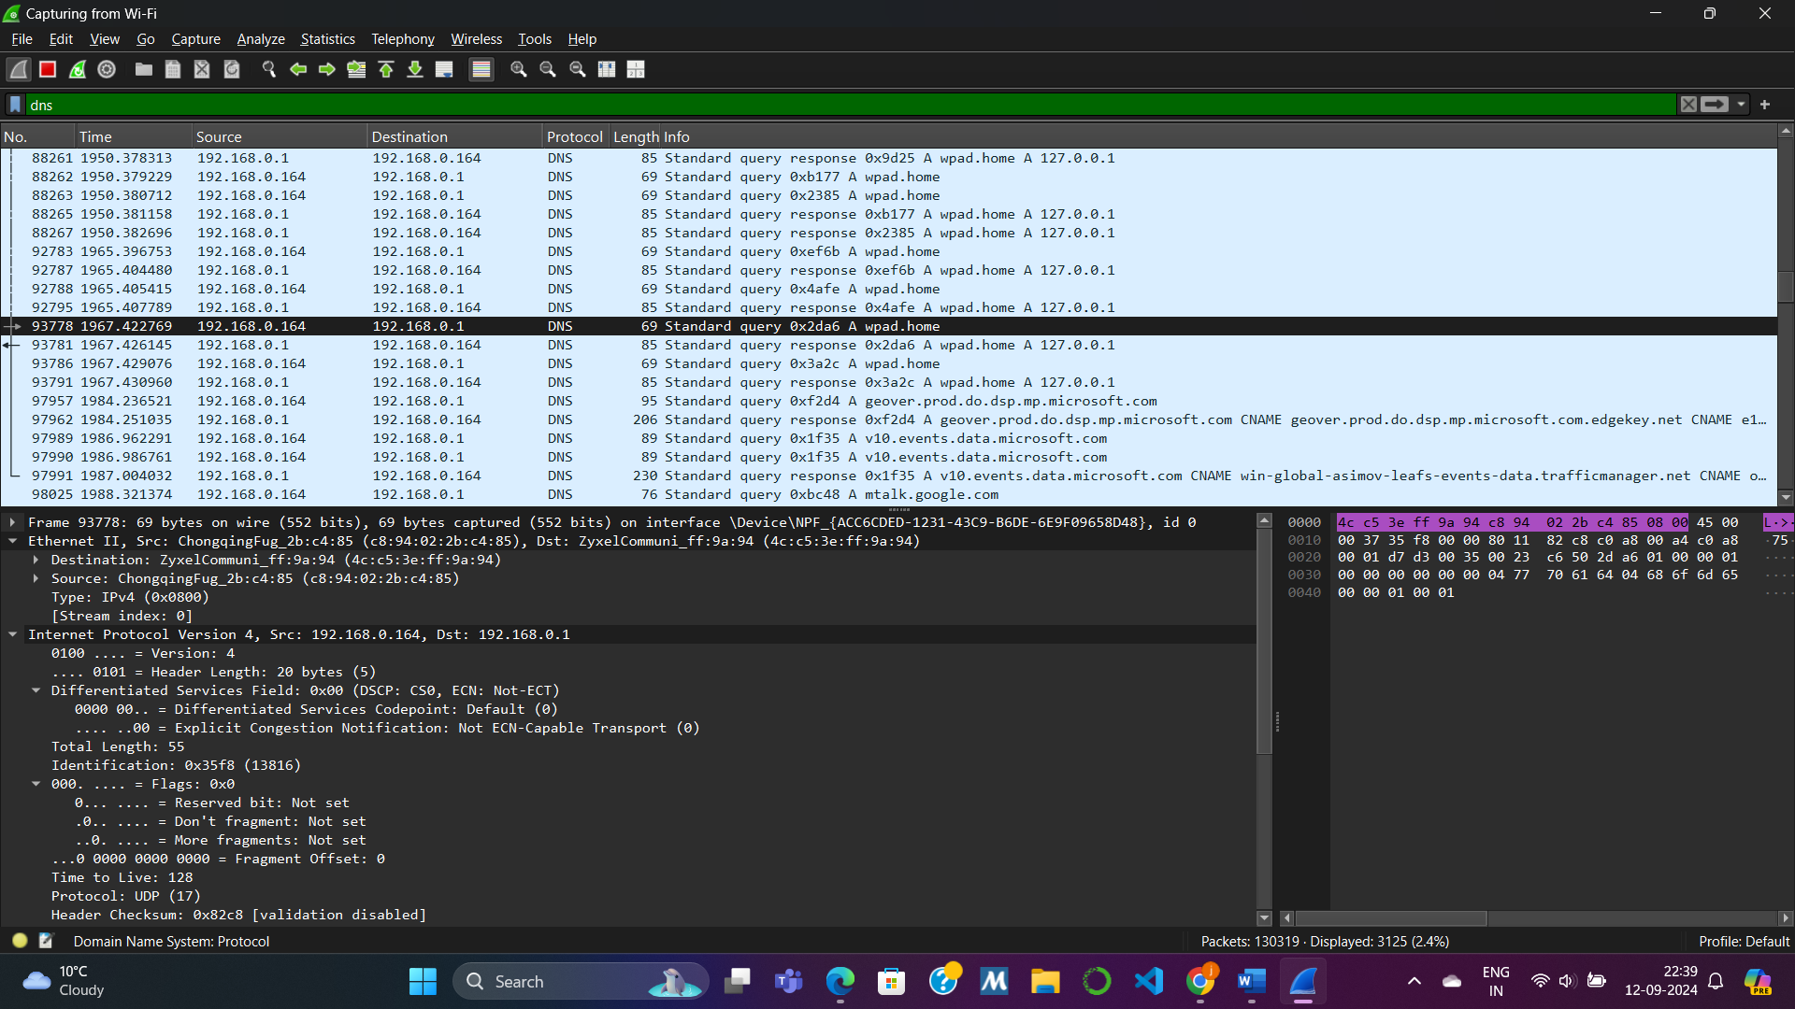

1. DNS Packet Analysis:

· Device IP: 192.168.0.164

· Destination IP: 192.168.0.1

· IP Version: IPv4

· Transport Layer Protocol: UDP (matches with packet details)

· IP Header Size: 20 bytes

· Payload Size: 27 bytes (27 - 20)

· Fragmentation: Not fragmented ("Flags: Don’t fragment")

· Other Important Fields: Total Length: 55 bytes, TTL: 128

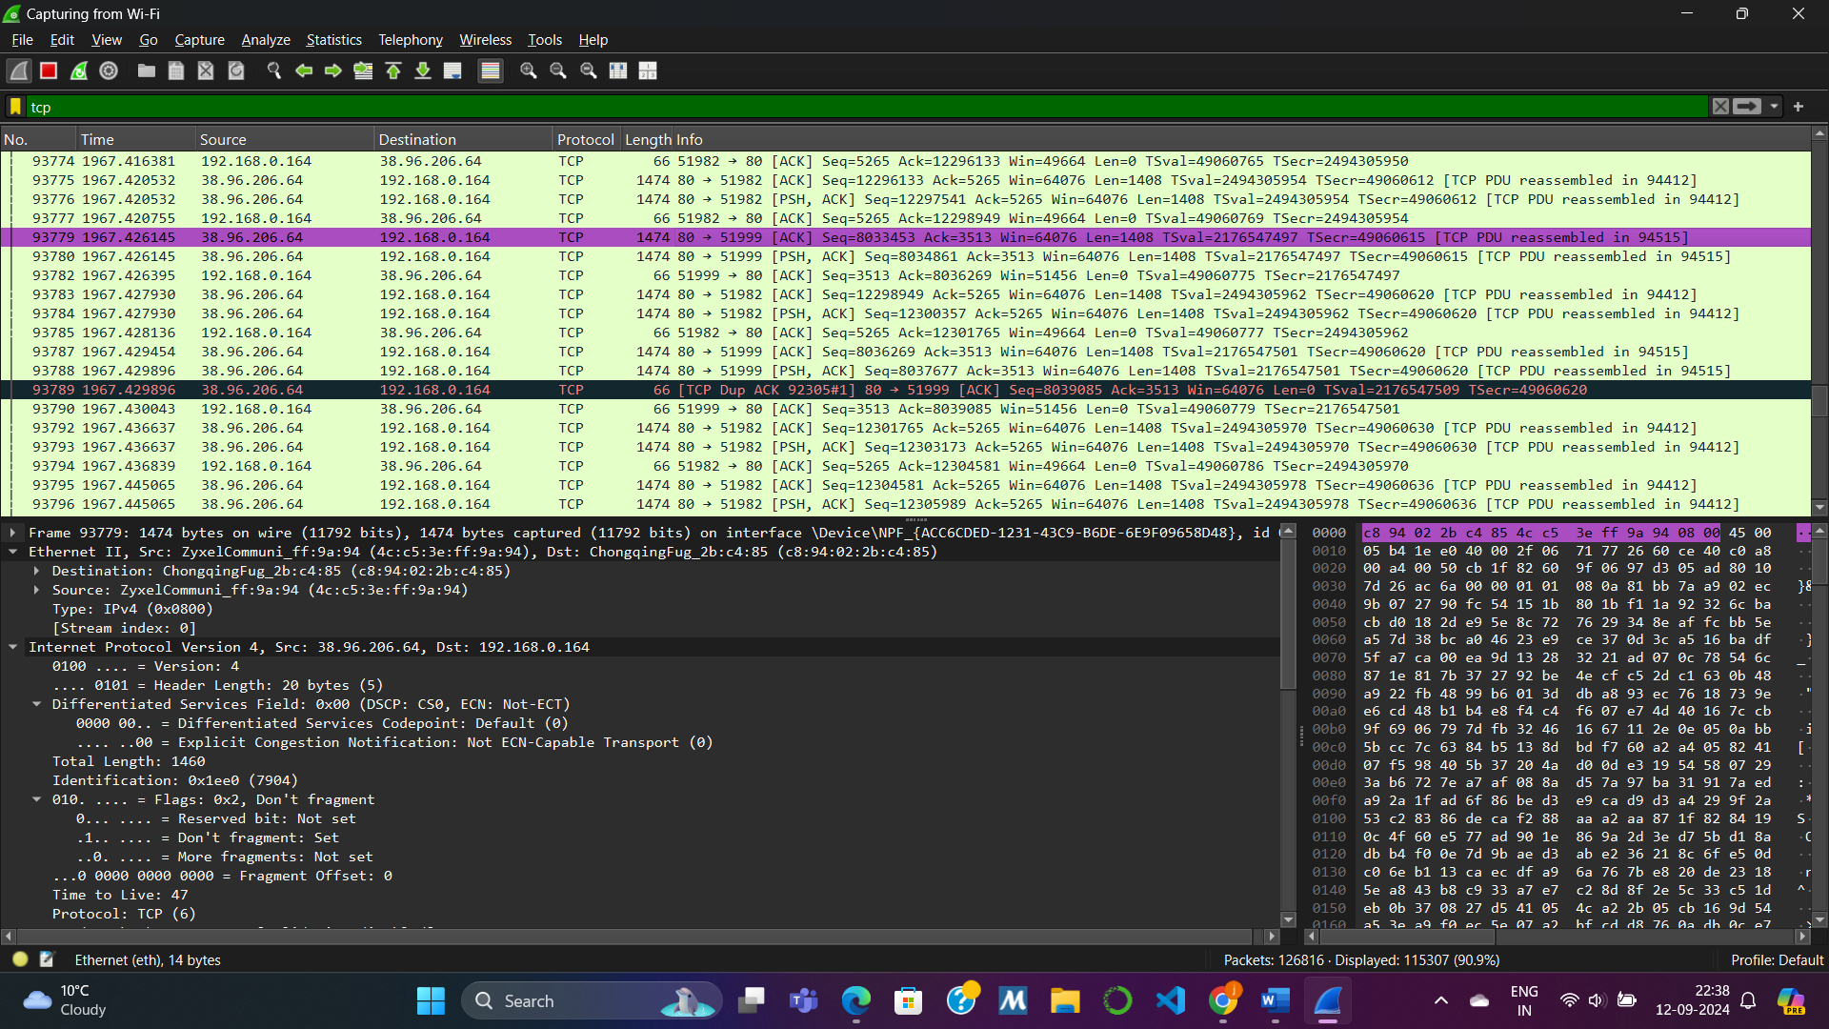

2. TCP Packet Analysis:

· Device IP: 192.168.0.164

· Destination IP: 38.96.206.64

· IP Version: IPv4

· Transport Layer Protocol: TCP (matches with packet details)

· IP Header Size: 20 bytes

· Payload Size: 1406 bytes (1406 - 20)

· Fragmentation: Not fragmented ("Flags: Don’t fragment")

· Other Important Fields: Total Length: 1460 bytes, TTL: 47

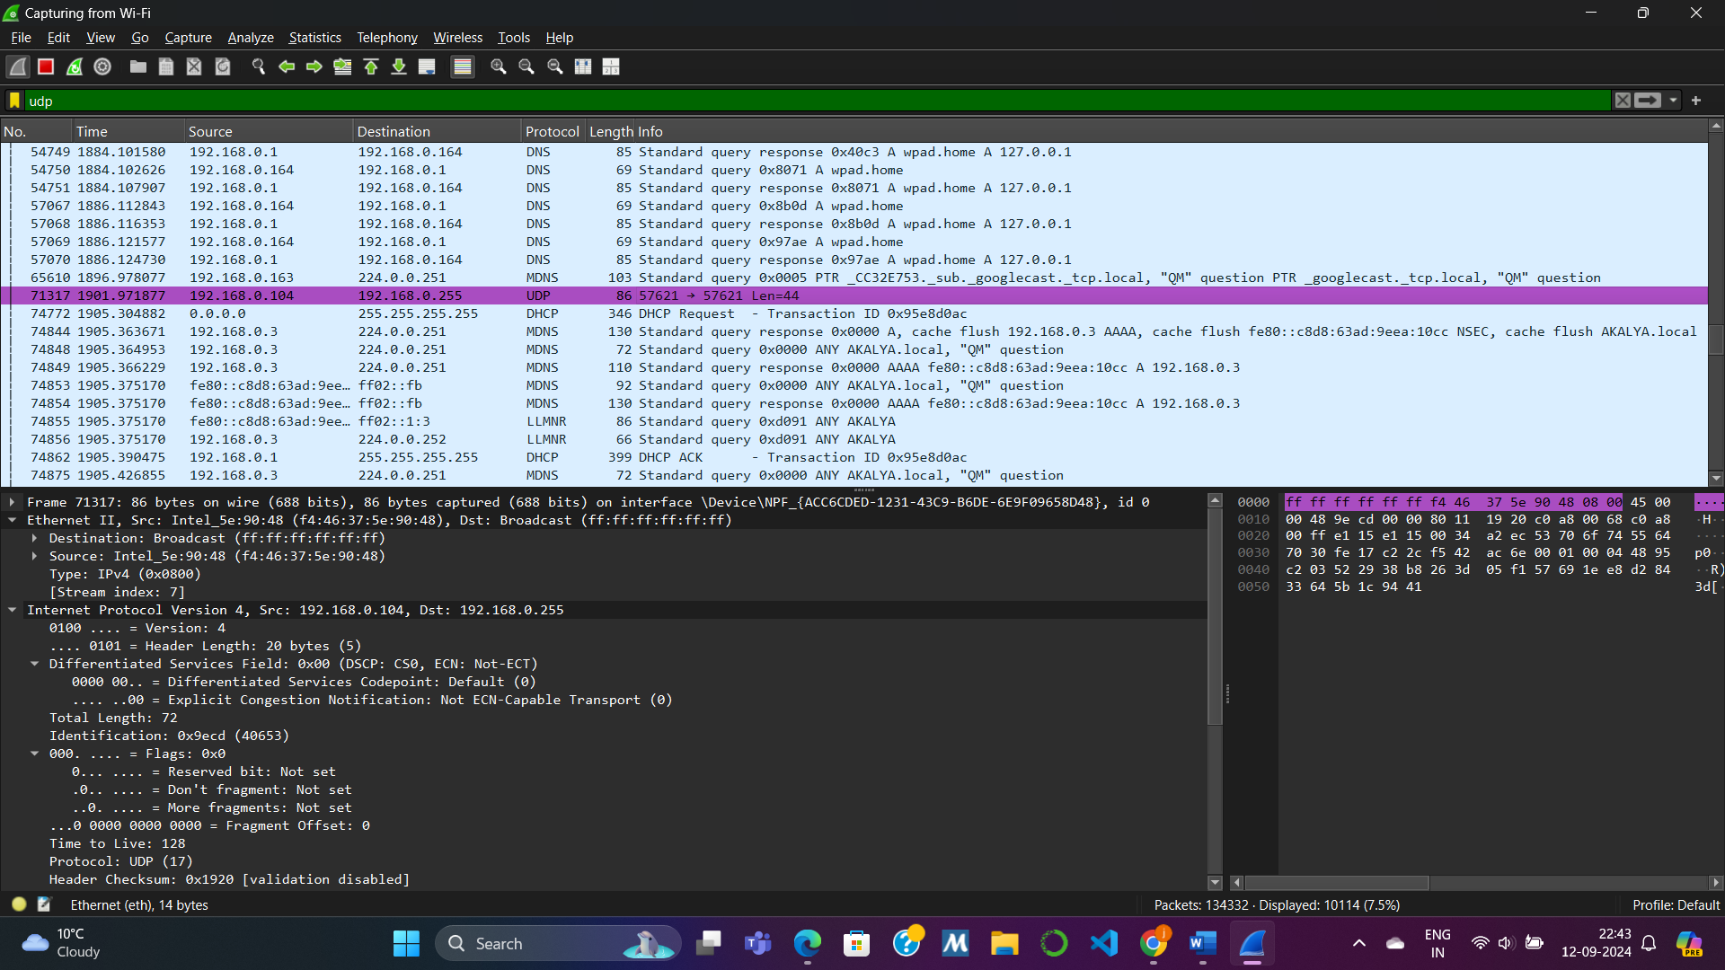

3. UDP Packet Analysis:

· Device IP: 192.168. 0.104

· Destination IP: 192.168.0.255

· IP Version: IPv4

· Transport Layer Protocol: UDP (matches with packet details)

· IP Header Size: 20 bytes

· Payload Size: 20 bytes (20 - 20)

· Fragmentation: Not fragmented ("Flags: Don’t fragment")

· Other Important Fields: Total Length: 72 bytes, TTL: 128

Activity 2   
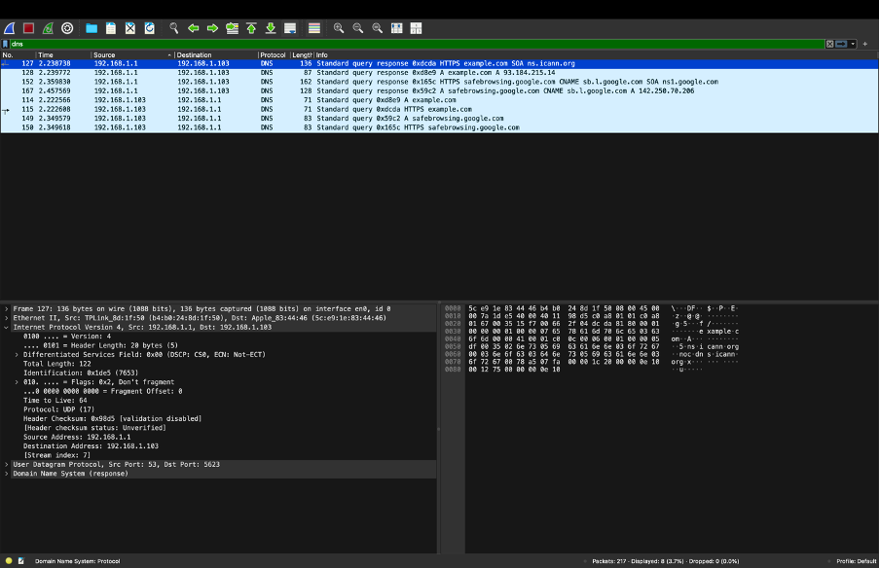  
**1. Sending a Present:**

· **Steps:** Drop off at local post → Regional sorting → International transit → Customs → Local delivery.

**2. Network Message Analogy:**

· **Steps:** Data creation on PC1 → Routed through local network → Internet transit → Routers/Firewalls → Delivered to PC3.

**3. Network Configuration:**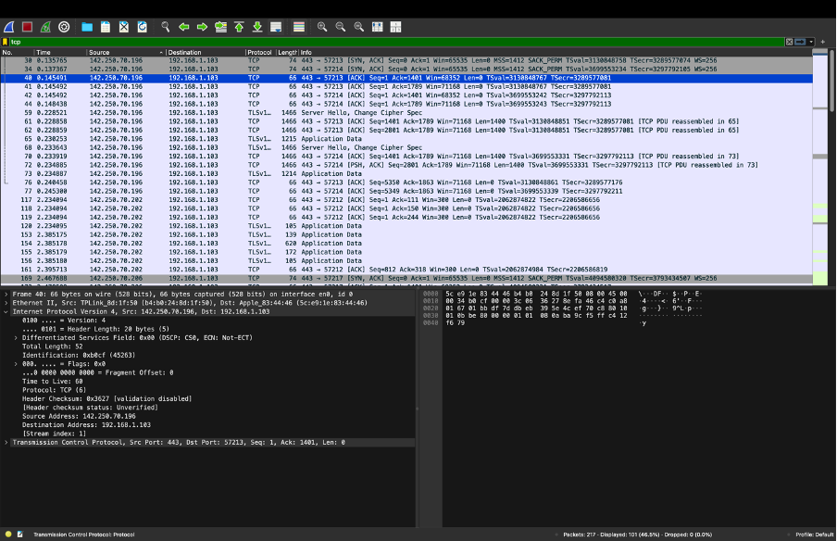

· **Archit (Router):**

1. LAN1: IP 10.1.1.1, Subnet 255.255.255.0

2. LAN2: IP 192.168.1.1, Subnet 255.255.255.0

· **Pranika (PC1, LAN1):** IP 10.1.1.2, Subnet 255.255.255.0, Gateway 10.1.1.1

· **Geetanshi (PC2, LAN1):** IP 10.1.1.3, Subnet 255.255.255.0, Gateway 10.1.1.1

· **Nadia (PC3, LAN2):** IP 192.168.1.2, Subnet 255.255.255.0, Gateway 192.168.1.1

· **Jasveena (PC4, LAN2):** IP 192.168.1.3, Subnet 255.255.255.0, Gateway 192.168.1.1

**4. Packet Journey from PC1 to PC3:**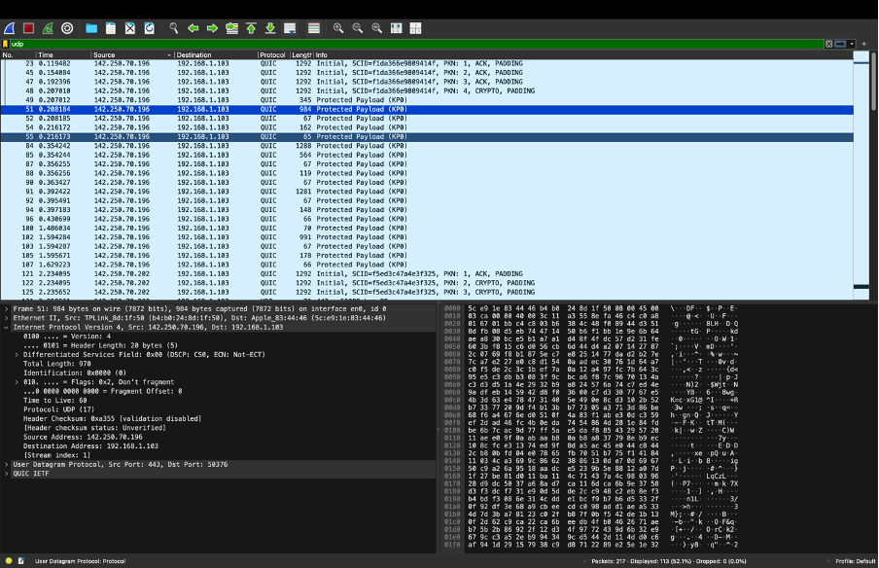

* **Step 1:** Pranika (PC1) sends the packet to Archit (Router) via gateway 10.1.1.1.
* **Step 2:** Archit (Router) forwards the packet to LAN2 through IP 192.168.1.1.
* **Step 3:** Switch 2 directs the packet to Nadia (PC3) based on its MAC address.

Activity 3 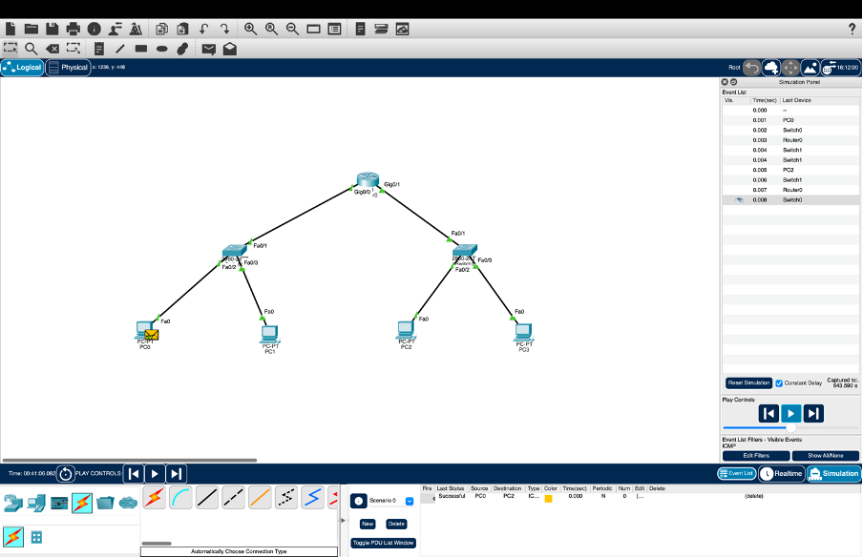  
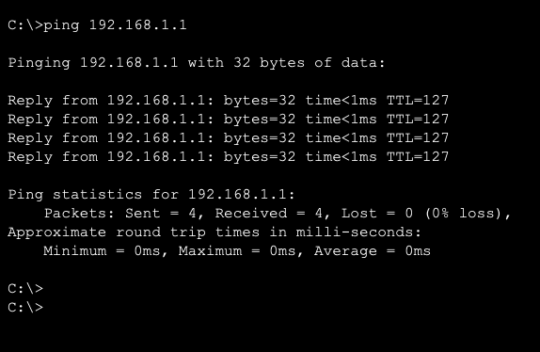

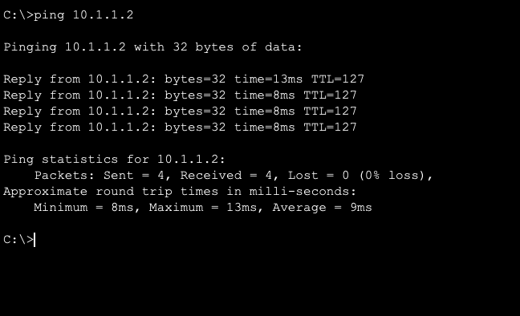

QUESTION :

Consider we have a network with a subnet along with prefix 192.168.40.128/26. Can you list down two IP addresses that can be assigned to two PCs connected to this network?

* For a network with the subnet prefix `192.168.40.128/26`, here’s how we can determine the IP addresses that can be assigned to two PCs:

1. Network Address: `192.168.40.128`

2. Subnet Mask: `255.255.255.192` (which corresponds to `/26`)

3. Broadcast Address: `192.168.40.191`

4. Usable IP Address Range: From `192.168.40.129` to `192.168.40.190`

Two IP Addresses for PCs:

1. First Usable IP Address: `192.168.40.129`

2. Second Usable IP Address: `192.168.40.130`

These addresses are within the usable range for devices in this subnet and can be assigned to PCs connected to this network.

